page2image568

Tableau

Lesson-End Project Solution



**Sales Dashboard**

**Step 1:** Create a table with measure names in the columns shelf. This will bring all the measures into view. Also, bring region and order date into the filters shelf. Format the measures as dollars, percentages, or units. Rename the sheet as “Profitability Statistics.”

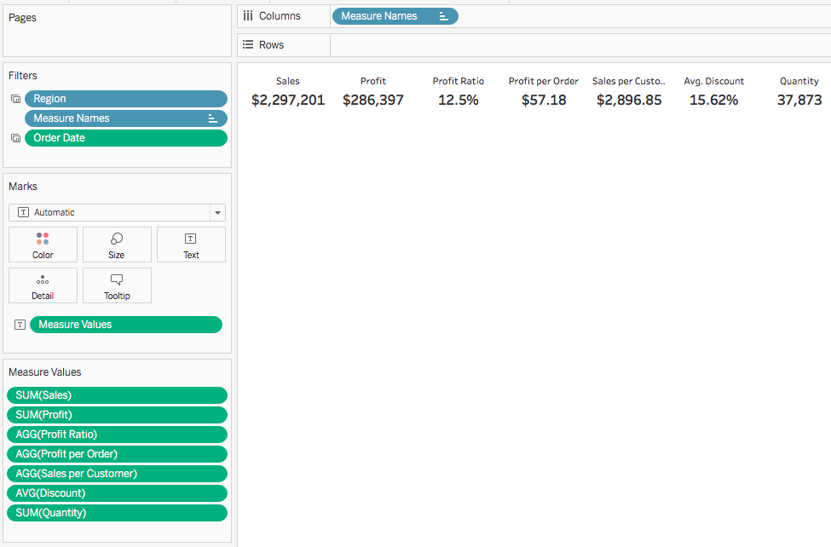

**Step 2:** Create a map by dragging latitude and longitude into the view. Add country to the detail shelf and drill down to state. Add sales to the size shelf and profit to the tooltip. Add profit ratio to the color shelf. Add order date, region, and profit ratio to the filters shelf as you will need these later. Change the color coding to “Red-Green Diverging.” Rename the worksheet as “Sales Map.”

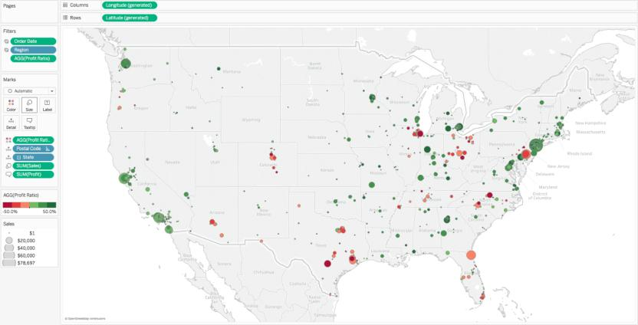

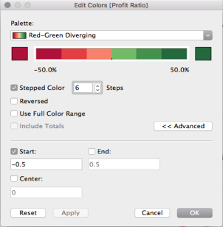

**Step 3:** Create a table with month of order, date in the columns shelf and segment and sales in the rows shelf. Rename the worksheet as “Sales by Segment.”

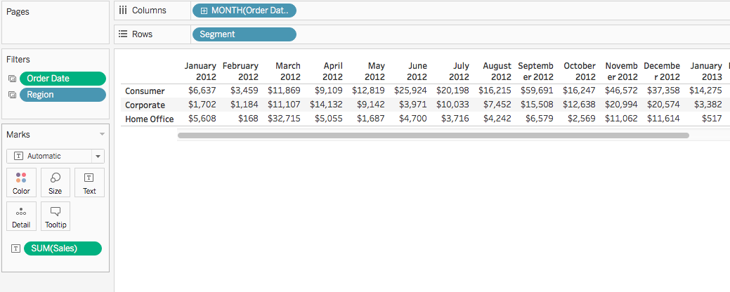

**Step 4:** Create a calculated field that specifies if an order is profitable or not

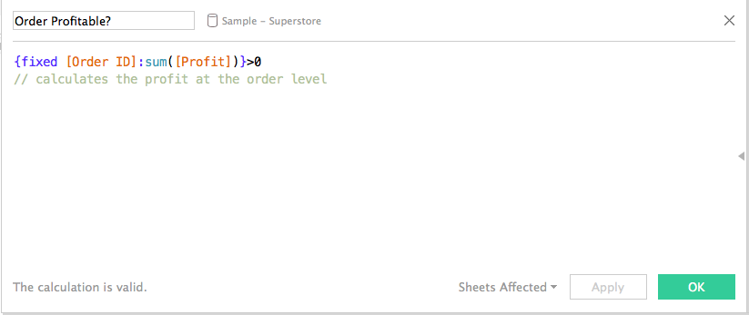

**Step 5:** Apply the formula to the table  
  
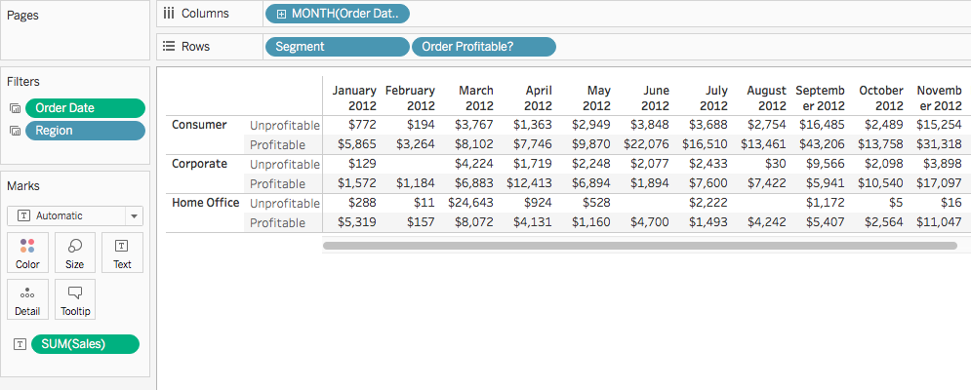

**Step 6:** Use the “Show Me” feature in Tableau to create a line chart

**Step 7:** Duplicate the “Sales by Segment” worksheet and replace the Segment dimension with the Category dimension. Rename the sheet “Sales by Category.”

**Step 8:** Create a dashboard with the “Probability Statistics” view at the top, the “Sales Map” below that, and the “Sales by Segment” and “Sales by Category” views bayside each other at the bottom of the page.

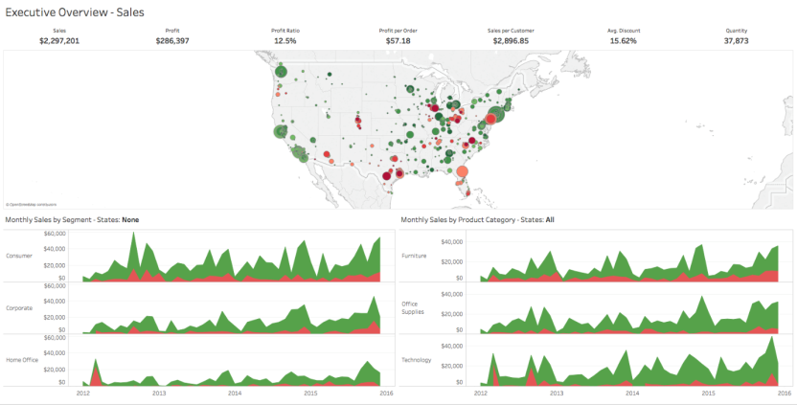

**Step 9:** From the Sales Map tab, add Filters for **Order Date**, **Region**, and **Profit Ratio**. Set up the Filters to impact all four views in the dashboard.

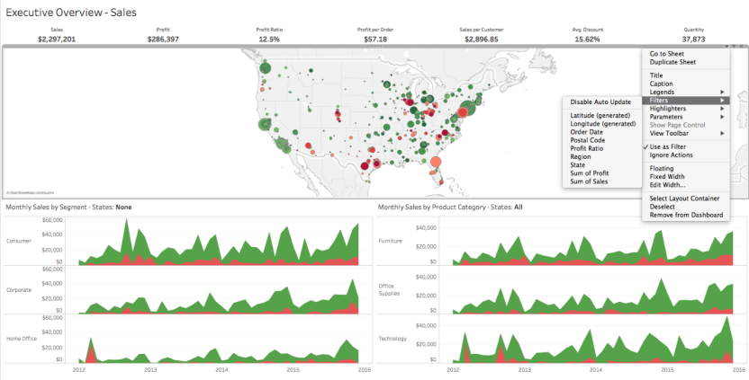

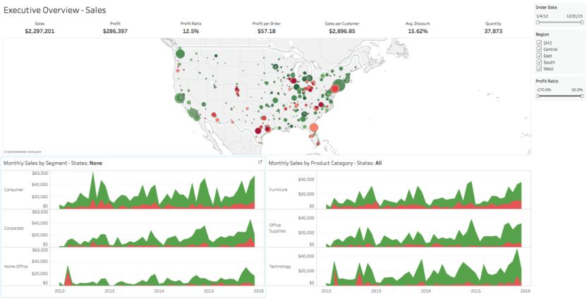

**Step 10:** Create and add a Filter Action so that when the user clicks on the marks in the map, the other views are filtered to show data for the selected mark(s). Set up the Action so that it is triggered when the user clicks on a mark (or marks) within the map. Set up the Action so that the filter is removed and all values are shown when the user clears the filter.

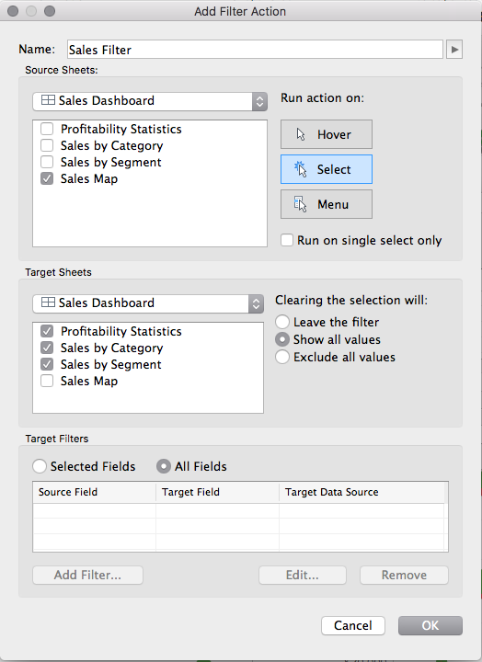

**Step 11:** Save your workbook as “Sales Dashboard”